HISTORY OF THE SWISS BALL

- The first use of a ball in exercise actually dates back to the 2nd century A.D. listed in Greek literature.
- Swiss ball or stability ball was originally developed in the early 1960s by an Italian manufacturer ,Aquilino Cosani.
- Mary Quinton, a British physiotherapist working in Switzerland, began using these balls in treatment programs for newborns and infants and subsequently introduced them to the UK.
- Dr.Susan Klein-Vogelbach, a founding director of a physical therapy school in Basel, Switzerland ,was the first to use these balls with adults who had orthopedic or other medical problems.
- Although the balls are Italian in origin, American physical therapists first witnessed their use in Switzerland,and this was how the term “Swiss Ball” was born.
- It was introduced to the United States in 1989 by Joanne Posner-Mayer,and phsical therapists began using the balls for neurological,orthopedic and fitness programs.

The Swiss ball is now known by many names including Gym Ball, Body Ball, or Gymnastic Ball and is widely employed in fitness and training programs for many elite atheists and teams

Benefits of using a swiss ball
- Low cost
- Coordination and proprioception are developed at the same time
- Multifunctional
Out comes of using swiss ball:
- Improved posture
- Enhanced Muscle tone
- Greater strength and control of the active and stabilizing muscle groups
- Increased agility and speed
- Reduced risk of injury

Safety and special consideration:

1.Swiss Ball Sizing:
General rule states that, when users are seated on the ball, their hips are slightly higher than knees and legs should be parallel to the floor and feet should be flat on the floor. If the legs are below the parallel level, users will be forced to use poor posture for some exercises.
Make sure that the body is not struggling to keep the ball steady
2.Exercise area
Make sure you are working out on a non-slip
debrie-free floor
3.Clothing
-Avoid baggy or slippery dressing garments
-Foot wear shouldn’t be heavy or studded and must permit good gripping.
4.Weights
In some progressions of exercises weights might be included .Remember never use weight that you cannot lift comfortably
5.Ensure all equipments is in good working order
Always use an anti-burst ball, which is designed to take up to at least 600lbs(300kg)and never let the combined weight of the equipment and your body exceed that of the manufacturer’s recommendations.
6.Ball storage
Do not store the ball near heat sources or in very cold temperatures as this could affect the expansion properties of the material

7.Health
If the patient is not used to exercising or have a medical condition, do further inquiries before letting them commence any form of exercise.

Equipment that accompany :
- Physio Roll
- Stability cushion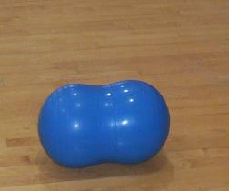
- Exercise mat
- Pole
- Medicine ball
- Resistive therapy band
- Ankle weights
- Set of dumbbells
- Pump

Before beginning the exercises,Neutral alignment and proper posture must be acheived
Neutral Alignment and Posture
- Before beginning an exercise programme using the swiss ball, it is important to make sure that the patient knows how to obtain Neutral Alignment and posture
Breathing
- Breathing needs to be coordinated with each movement that is done.
- Many people during this type of exercise have a habit of holding their breath which affects the oxygen content in blood and leads to heart and lung complications.
2 key points remember to tell your patients:
1.Breathe in before a movement
2.Breathe out during the movement.
-Teach your patient breathing exercises using a towel or a scarf .

Again, gaining neutral spine
The following positions ensure effectiveness and safety of the exercises as well as activating the lower Abdominals and pelvic stabilizing muscles, which form a protective and supportive girdle to the Lumber spine

*Finding Neutral—Supine

-Pull the navel backward to the floor to tighten the lower abdominal muscles(ask the pateint to put their fingers just above the pelvic bone,so they can feel the deeper muscles tighten as they pull the stomach muscle in) transversus abdominus,internal oblique)
-The back must not arch or hollow
-Breathing should be relaxed and steady
-this exercise helps in reduction of compression on the spine by as much as 40% ,as well as promoting the natural function of these muscles(Richardson et al.1999;wirhed1990)
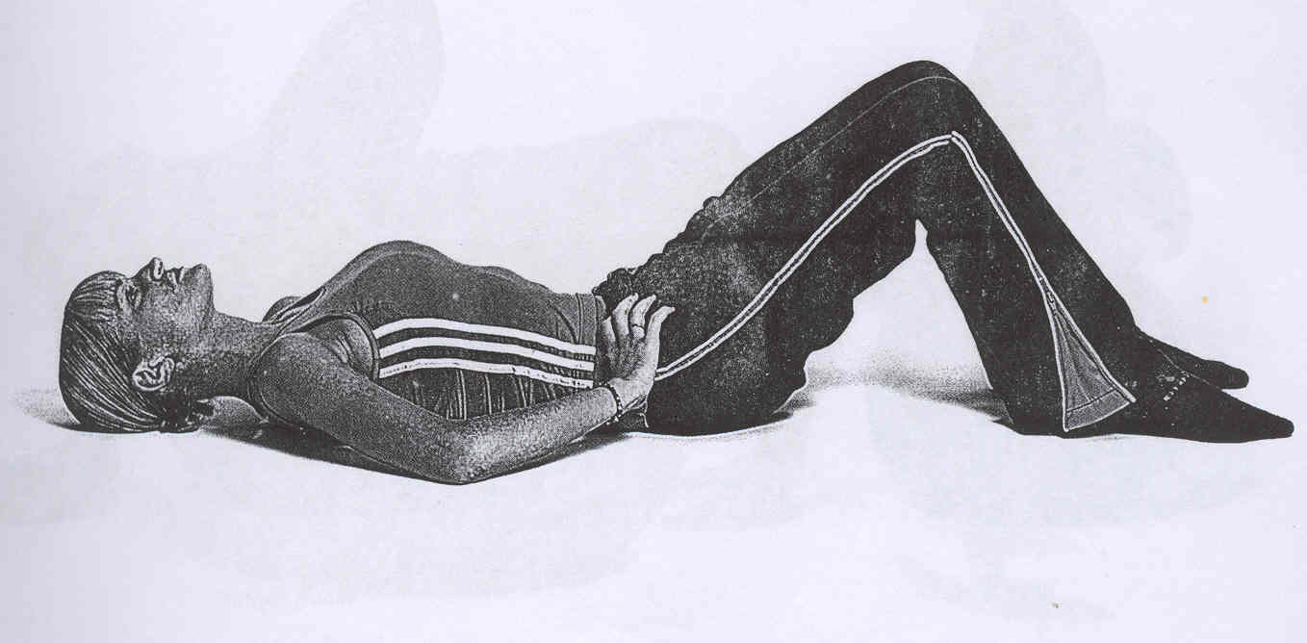

*Sitting Alignment
Sit on the ball with the back straight
-Feet should be shoulder width apart
-Tighten Lower abdominal muscles
-Relax shoulders and gently squeeze shoulder blades together to prevent shoulders from rounding
-Breathing should be relaxed and steady with the stomach muscles not to move with breathing
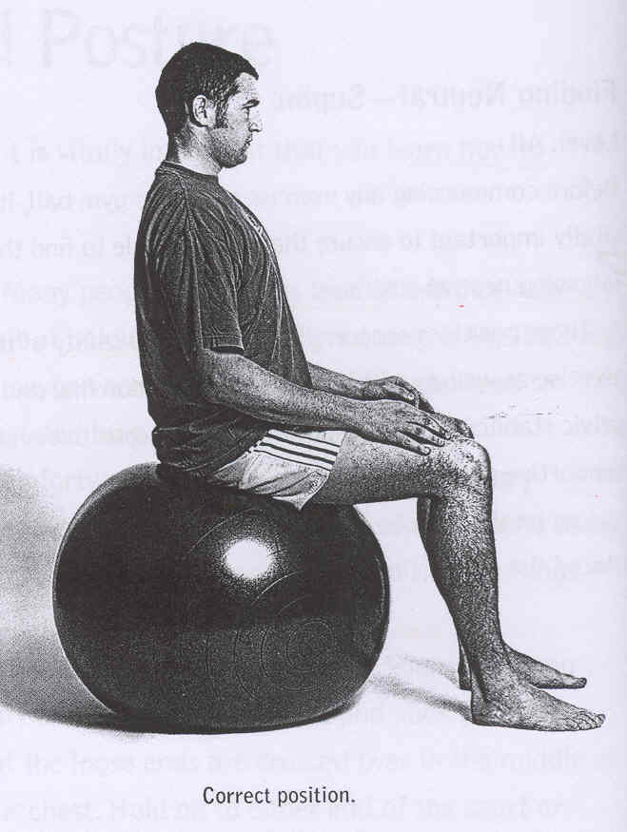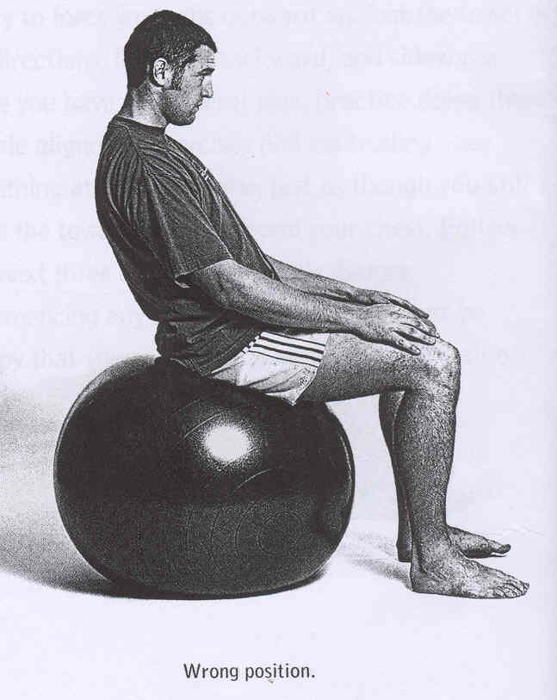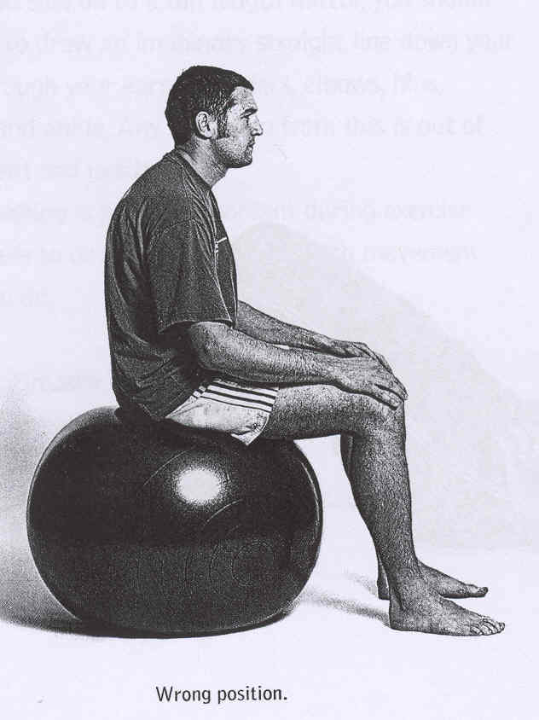

*Finding Neutral—Prone
-Kneel with the ball under the abdomen
-Roll forward until the ball is under knees or shins
-Pull in the Abdominals and glutes so that the spine becomes straight
-During all the exercise the spine remains level and should not be allowed to sag or arch
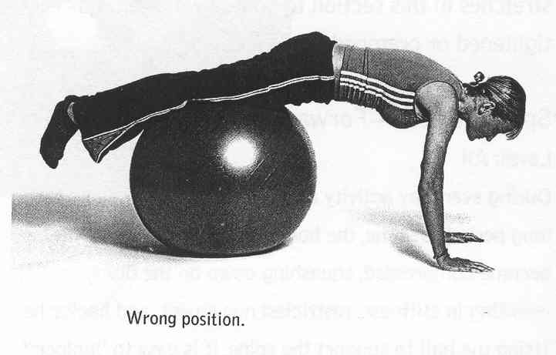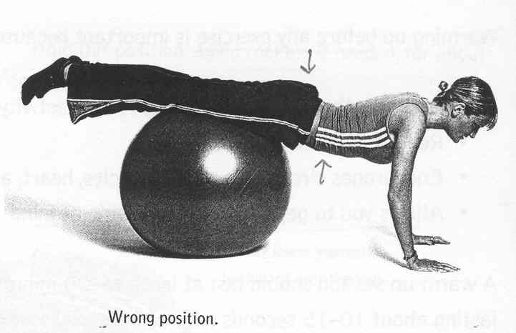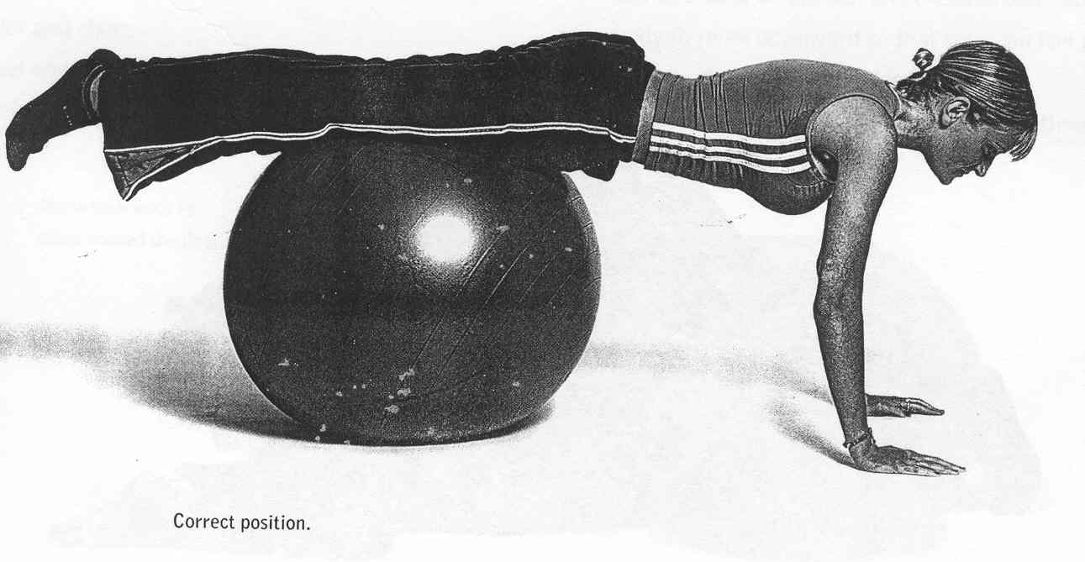

Warm Up and Cool Down
- A warm up session should last at least 15-20 mins and each stretch should be gentle and strong lasting from 10-15 seconds with no pain or burning sensation.
- Instruct your patient to concentrate on breathing techniques during the warm up activity

Spine Stretch
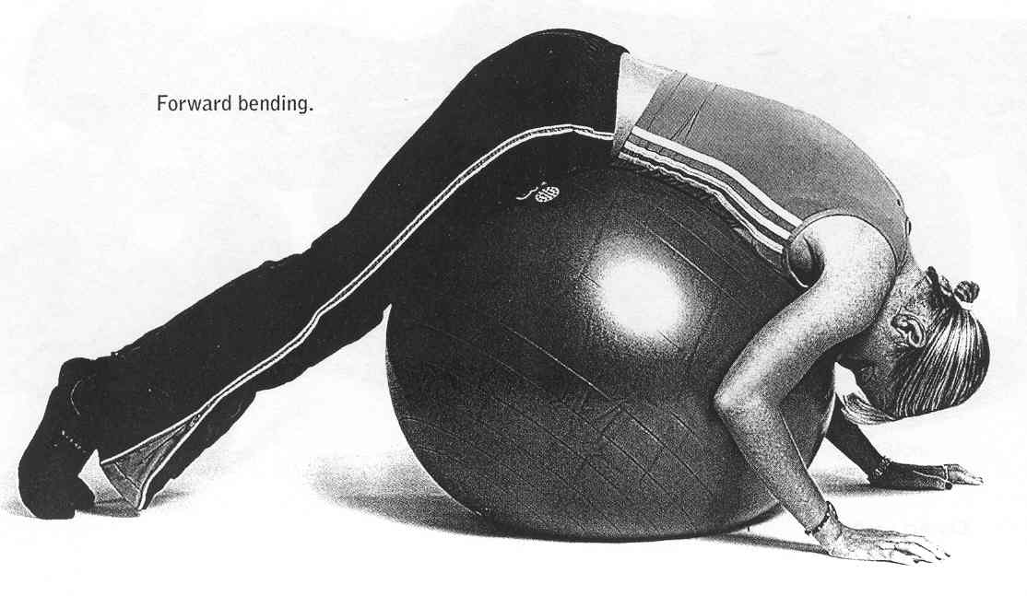

Flexion fwd bendind

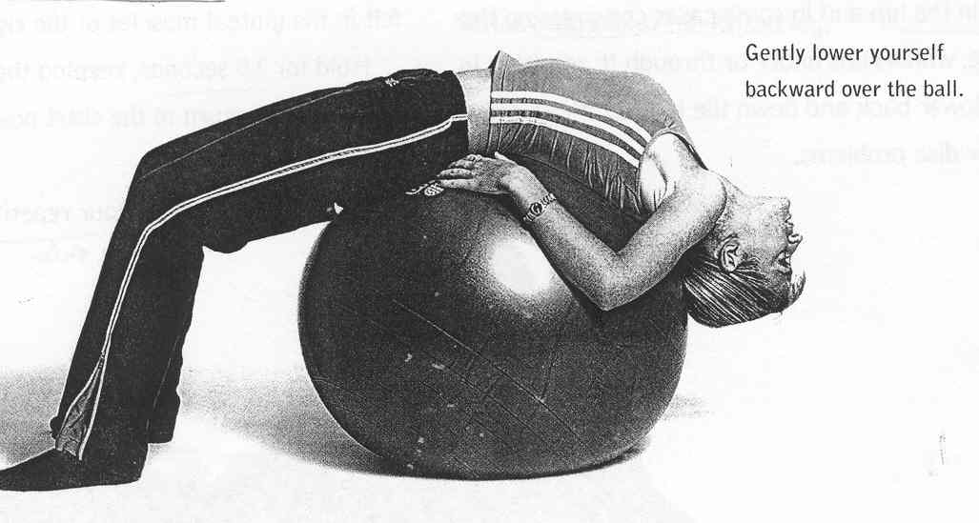

Extension backward bending
Shoulder girdle stretch
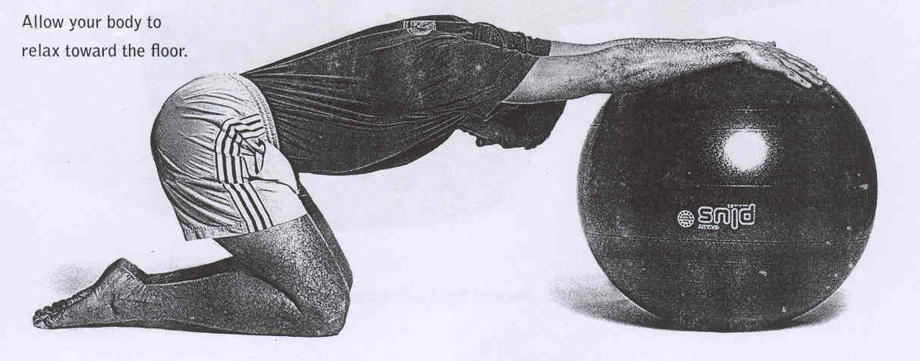

Shoulder girdle stretch
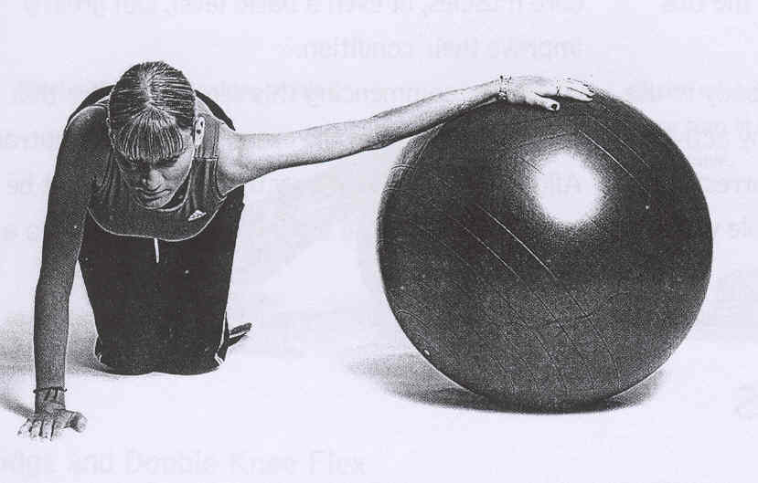

Pectoral stretch
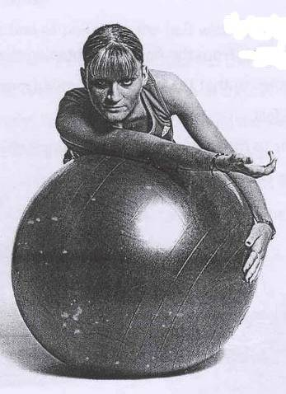 Rotator cuff stretch

Hip Musculature Stretch
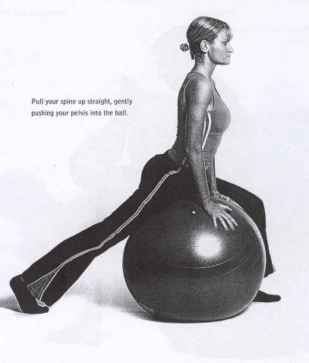 Hip Flexor stretch

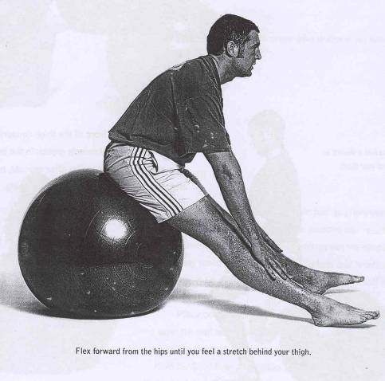 Hamstring stretch
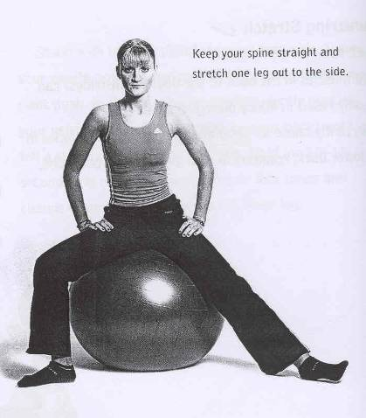
Adductor stretch
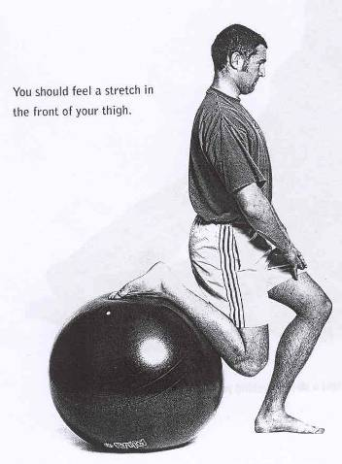Quad stretch

Core Stability
- The lower spine is inherently unstable in its own right. It has to rely on surrounding muscle groups for support.
- The muscles which form the “core” are the smaller spinal muscles and those of trunk and pelvic girdle. In short, everything between the ribs and the hips)
Beginners exercises
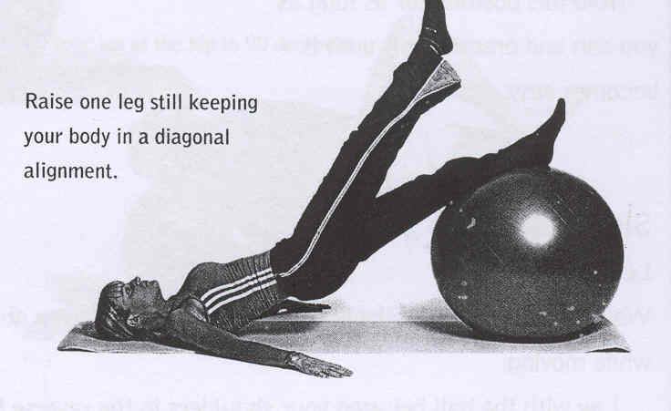 Bridge with leg lifts

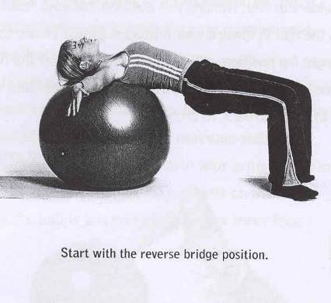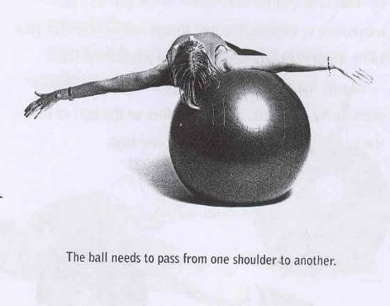 Side walks
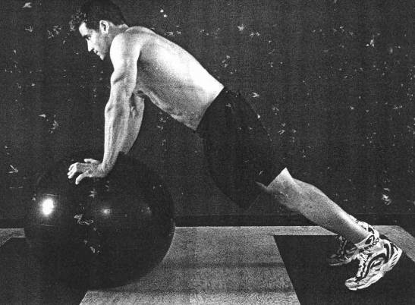 Balance Push up
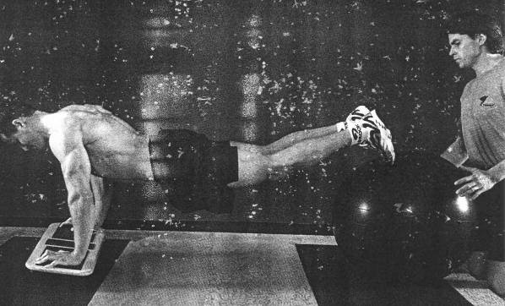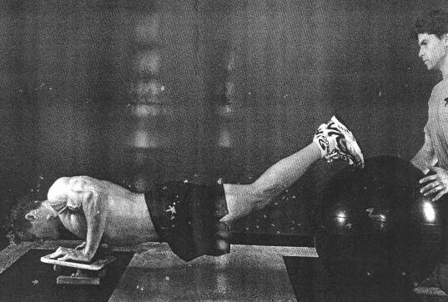 Reverse Balance Push up

Abdominals
- The shape of the ball pre-stretches the abdominals as the patient initiates the movement allowing the abdominals to work through a greater ROM.
- Weakness or dysfunction in this muscle group can lead to:
-Excess curvature of the lower back
-Protruding, weakened stomach muscles
-Inability to stabilize the pelvis when lifting one leg
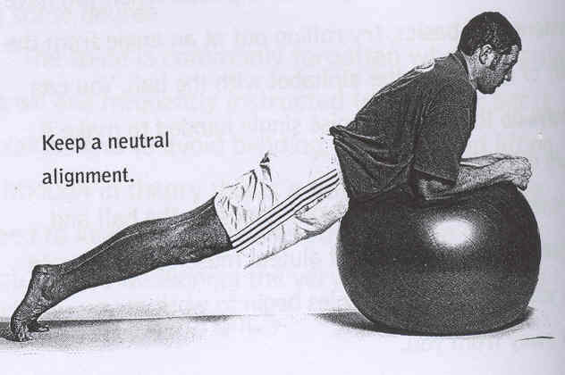 Basic crunch

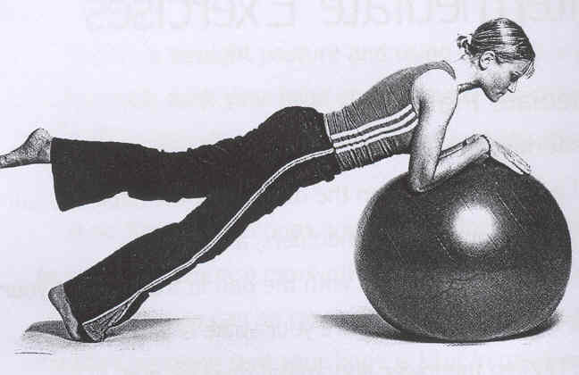Intermediate crunch
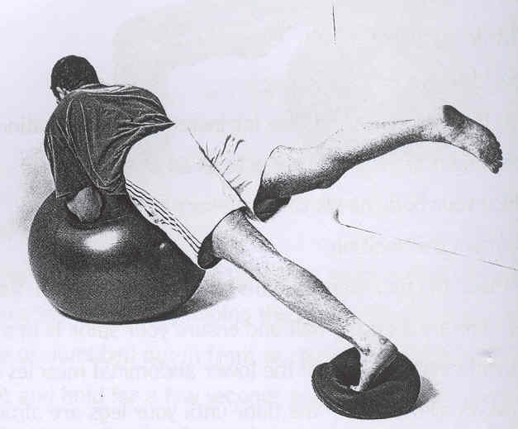 advanced crunch

Senior citizens
- Exercise on a swiss ball-provided to be moderate and of a basic level, is considered to be one of the safest one to be thrown out by senior citizens.
- For more stability you can introduce the physio-roll into the exercises.
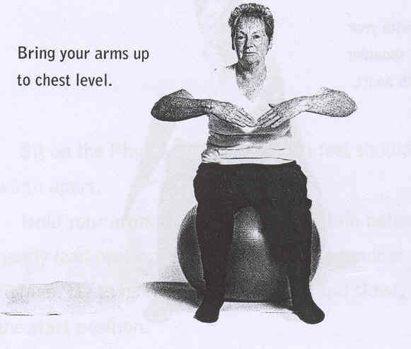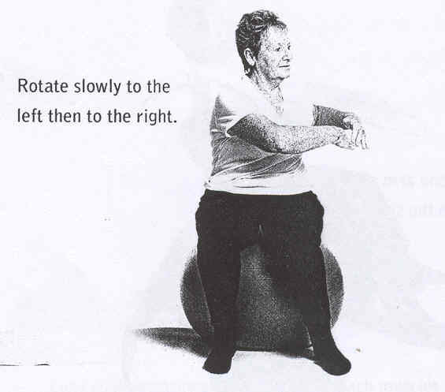 side rotation

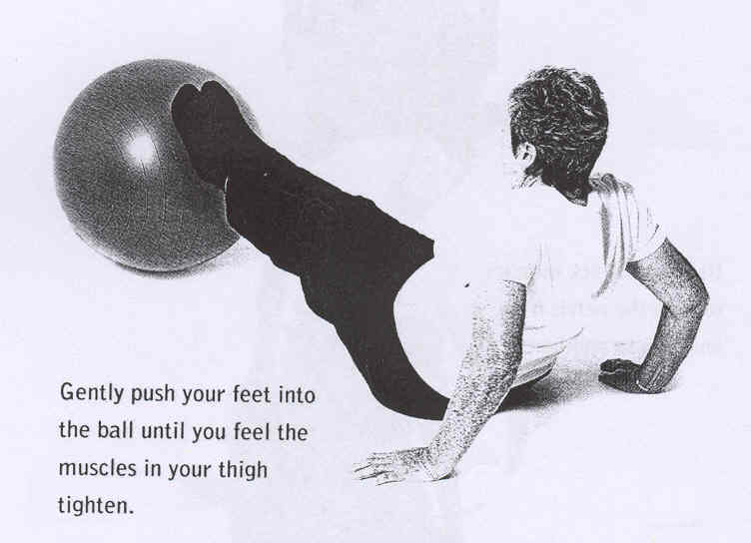 leg strengthening
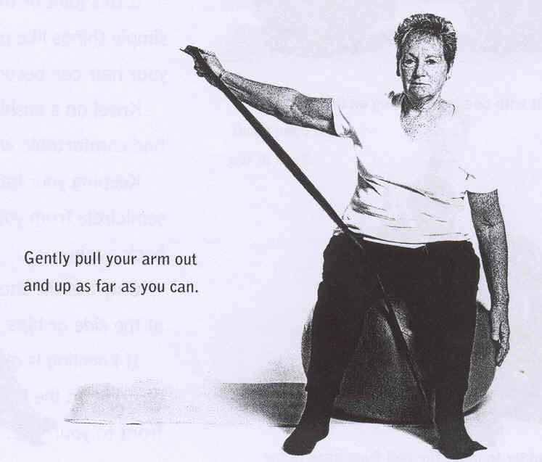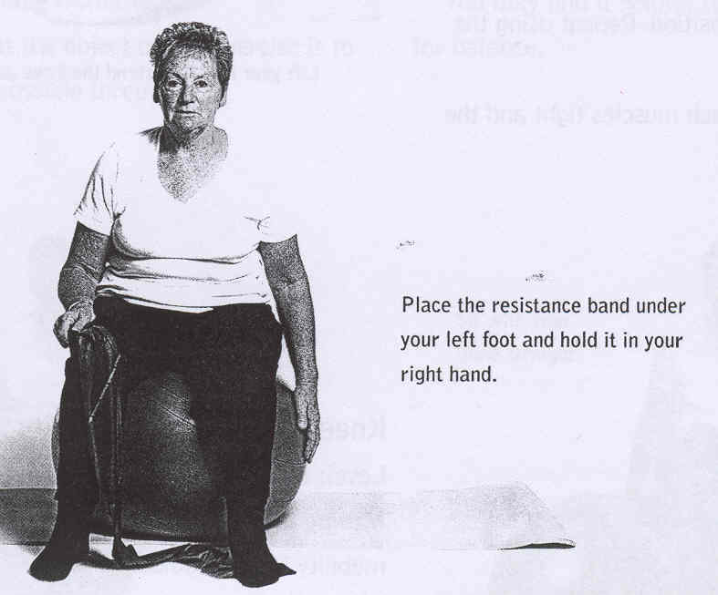 shoulder rotation

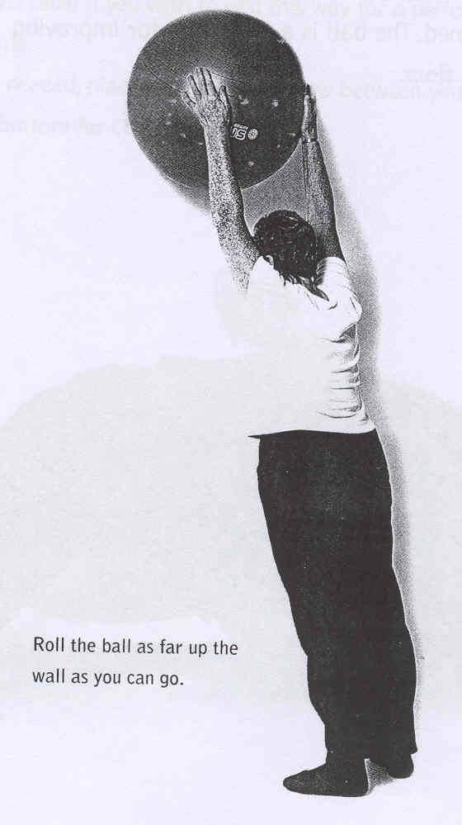 shoulder extension

Antenatal and postnatal
- The ball permits women specially in the later stages of pregnancy to perform exercises comfortably as it allows the pelvis to be level or slightly higher than the knees. This position creates a better posture leaving more room for the baby to move around.
- Exercise before the birth is important to keep the muscle strong in preparation process for the delivery
- Using physio roll may be an option for these exercises, enabling more stability and confidence for the mom.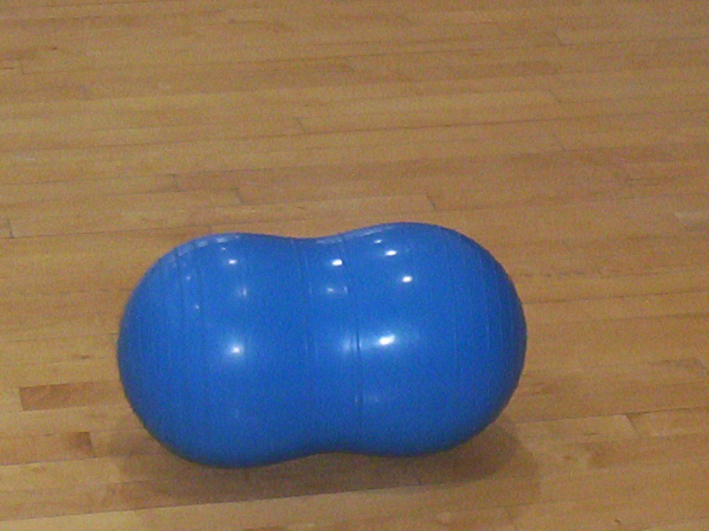
- Exercise ball have been more popular in the delivery room. It provides support in the kneeling or squatting positions and allow the mother to keep moving to ease the discomfort.

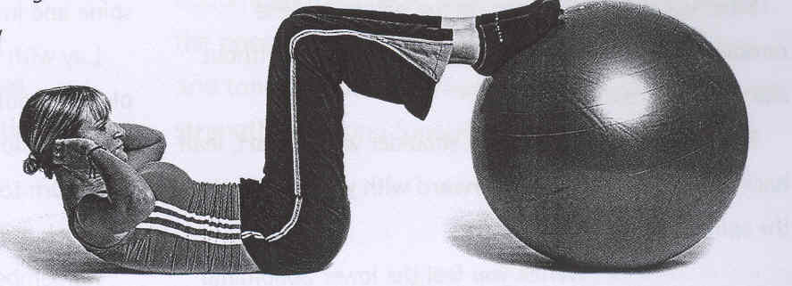

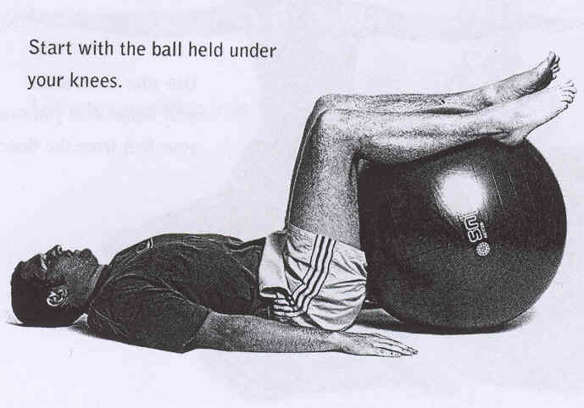

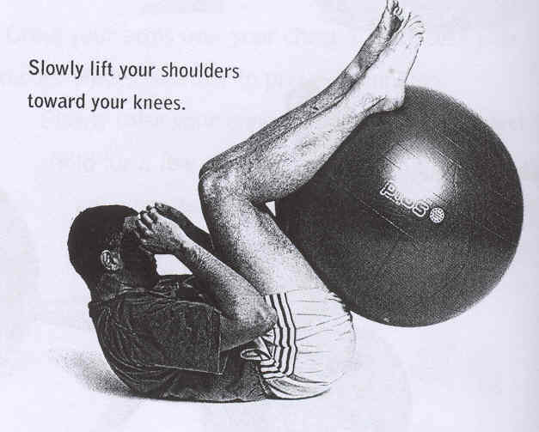

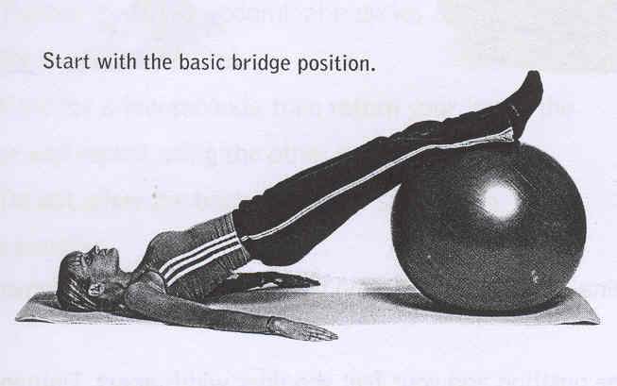

Methods of progression

- 1.Change the base of support
- 2.Increase The ROM
- 3.Vary the speed of the movement
- 4.Add resistance.
- 5.Close the eyes.

Exercises used in Treatment of scoliosis

